NET512

Designing and Implementing a Secure, Scalable, and Automated

Enterprise Network

Weekly Practical Plan — NQF Level 5 | 17 Credits

  - Week 3: Life of a Packet (10 Marks)

R1 | R2 | R3 | DNS-Server
10.10.10.1 | 10.10.10.2 / 10.10.20.2 | 10.10.20.1 | 10.10.10.10
255.255.255.0 | 255.255.255.0 | 255.255.255.0 | 255.255.255.0

DNS Configuration

16. Configure the routers as DNS clients, pointing to the DNS server in the topology.

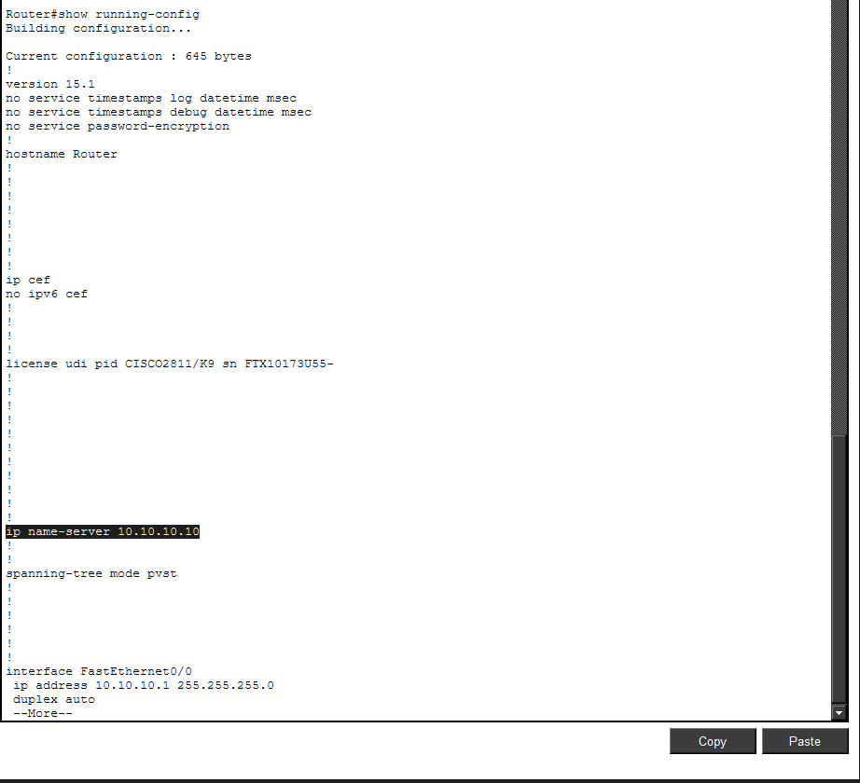
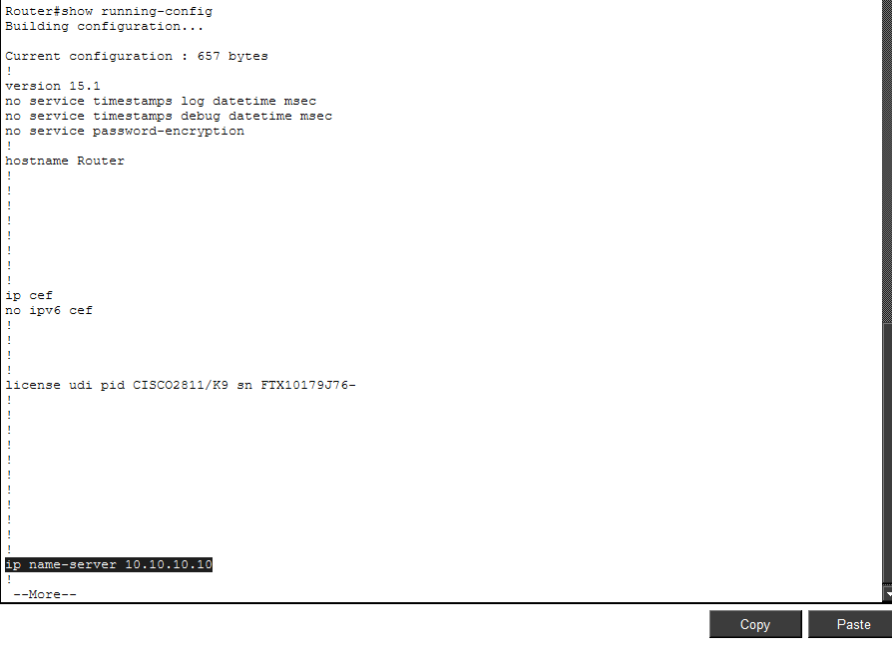
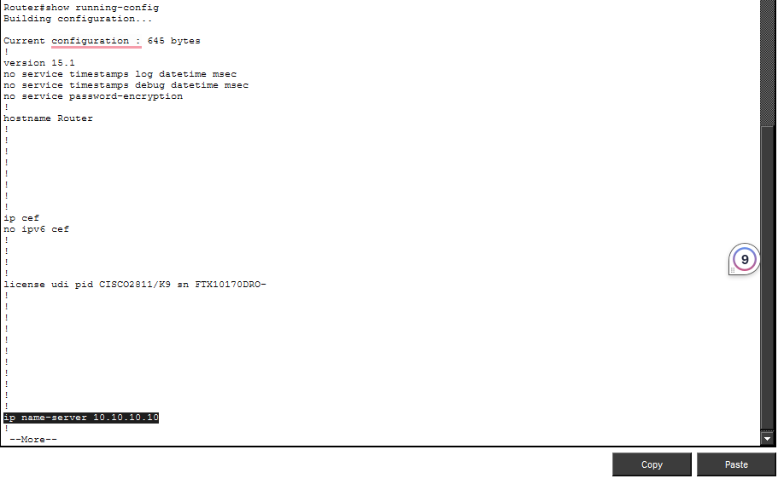

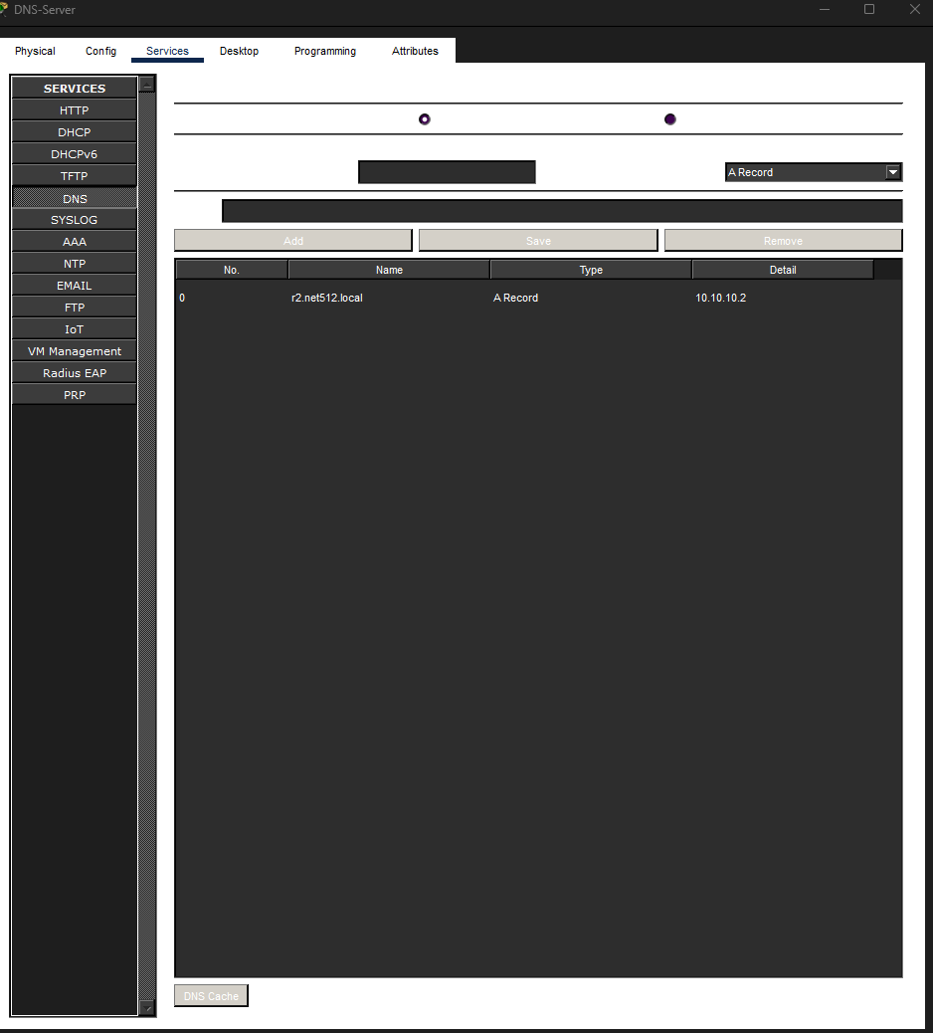

17. Test name resolution from a router by pinging a hostname instead of an IP address.


ARP Cache
18. Clear the ARP cache on a router, then generate traffic (e.g., a ping) to a directly connected neighbour.
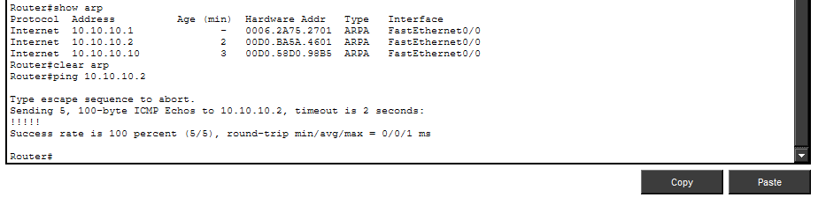

19. Examine the ARP cache on the routers with 'show arp' and identify the newly learned entry.
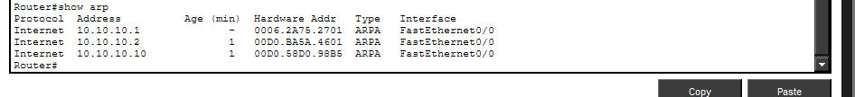

Reflection Questions (answer these in your submission):

20. What information does an ARP entry give you that a routing table entry does not?
An ARP entry provides the MAC address associated with an IP address, as well as the interface used to reach that device. A routing table provides information about where to forward packets but does not provide the device's MAC address.

21.Why does a router need to perform an ARP lookup even after it already knows the correct route from its

routing table?
The routing table tells the router the correct next hop or outgoing interface, but the router still needs the next-hop MAC address to create the Ethernet frame. ARP is used to find that MAC address so the packet can be de livered on the local network.

